DB 9.0 Panel Design Tips
Avoid Excessive Style Overrides
The new default styles are designed to have a modern aesthetic and provide a cohesive look for Ross products moving forwards. Please use style overrides only when you want to communicate something specific to the user, rather than trying to make your panel look different than the rest of DashBoard.
For example:
- Good: Using style overrides to make a “Factory Reset” button on your panel red, because you want to communicate danger.
- Good: Using style overrides to create a clickable map of physical layout of connectors on the back of your device, because you want to mimic that physical interaction.
- Bad: Using style overrides extensively because you want to achieve a different look and feel than standard DashBoard.
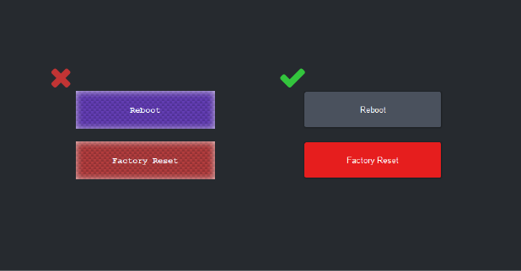
Of course, there are exceptions to every rule – For example, achieving dramatically different looks is a normal part of Creative Services’ role.

Give Elements Room to Breathe
It’s more important than ever to make sure your panel elements have a bit of spacing between them. This makes everything easier to visually understand and help prevent elements from visually bleeding into each other.
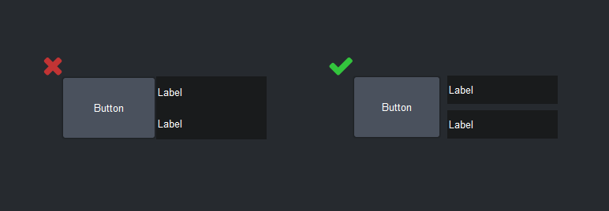
Be Careful with Borders
Too many borders can make your panel feel cluttered. Additionally, consider switching to “Thin” borders instead of “Etched” borders.
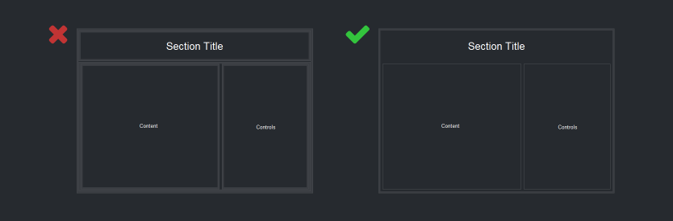

Keep Items Aligned
With the new clean look, keeping panel elements lined up is more important than ever. Elements out of alignment look messy and haphazard. If you’re building using PanelBuilder, DashBoard’s “Snap To Grid” function is great here! Just right click with PanelBuilder open and choose “Snap To Grid”. For more details on this, including how to change the grid size, see the DashBoard documentation.
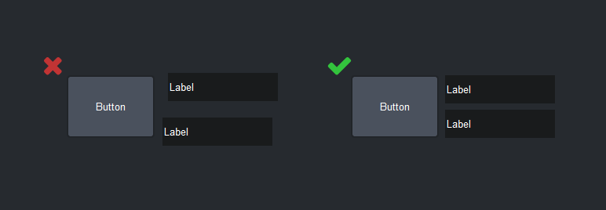

New Color Palette Options
We’ve introduced new color palette choices in PanelBuilder for:
- Dividing lines – #darkdivider and #lightdivider
- Dark overlays behind modals - #modaloverlay
- General colors: #red, #orange, #yellow, #green, #teal, #blue, #purple, #pink.
You can find these colors in the PanelBuilder color picker. The complete color picker options are:
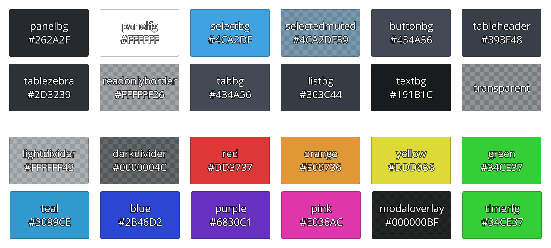
Existing Color Palette Options Have Changed
If you open an existing panel and text is illegible, it’s likely due to a small number of color palette options that have changed significantly. Previously DashBoard used a mix of dark-on-light and light-on-dark text. DashBoard Aura near-exclusively uses light-on-dark text, and some color options have changed to reflect this.
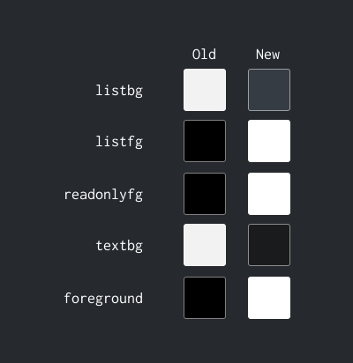

New features for Sliders
Non-labeled sliders have a new feature that allows you to show a fill up to the slider’s level. This can be helpful for helping a user “see” how large a value is, or to add semantic color to your slider (For example, for RGB gain sliders). Set “w.fillanchor” (max, mid, or min – chooses where the fill starts from) or “w.fillcolor” (any hex color – sets the color of the fill) in the PanelBuilder config options to enable this.
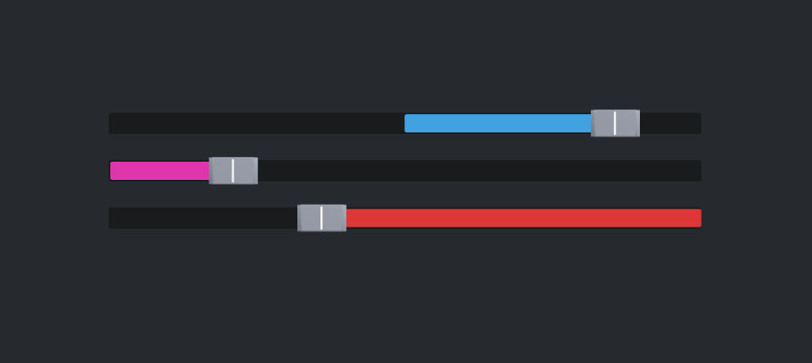
When you use this in your panels, make sure you set the “w.fillanchor” value such that the size of the color bar correctly reflects the magnitude of the value.
Brand Colors
DashBoard 9.0 does not have any special handling for the product-specific brand colors, but that functionality is coming soon. Keep your ears open for announcements on this topic!

